ARTIFACT
  - Full Workflow
The workflow begins with importing the dataset followed by cleaning it and then filtering it to maintain relevant records. The data was aggregated at the customer level to generate behavioral features, whilst a Python script was used to define the churn label. Following the selection of the final predictors as well as the target variable, three models were selected, namely Logistic Regression, Decision Tree, and Random Forest and they were trained and evaluated in Test and Score. Their performance was then assessed using the ROC Analysis and Confusion Matrix. This workflow ensures a structured and generalizable approach towards customer churn prediction using machine learning techniques.
Figure 1.1: Orange Data Mining workflow for customer churn prediction
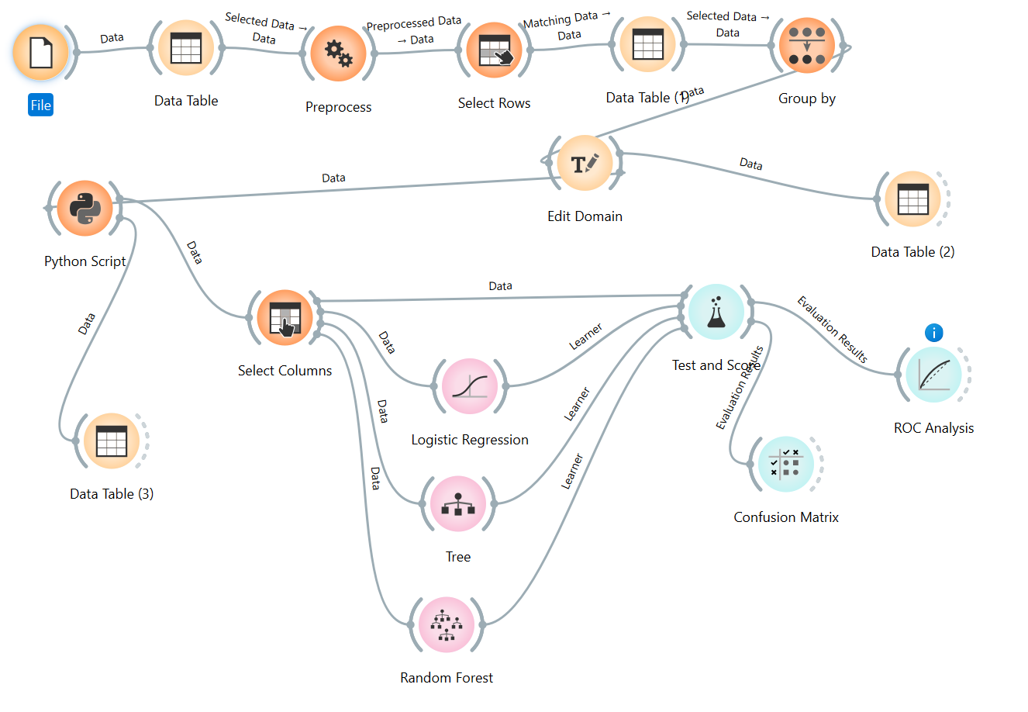

1.2 Loading of the Dataset
The orange workflow starts off with the File Widget, this is where The Online retail dataset: UCI Machine Learning Repository is imported into the system. The dataset is then subsequently observed in the first Data Table widget to review its structure as well as confirm that the variables have been loaded correctly.
Figure 1.2: Data loading and initial dataset inspection using File and Data Table widgets
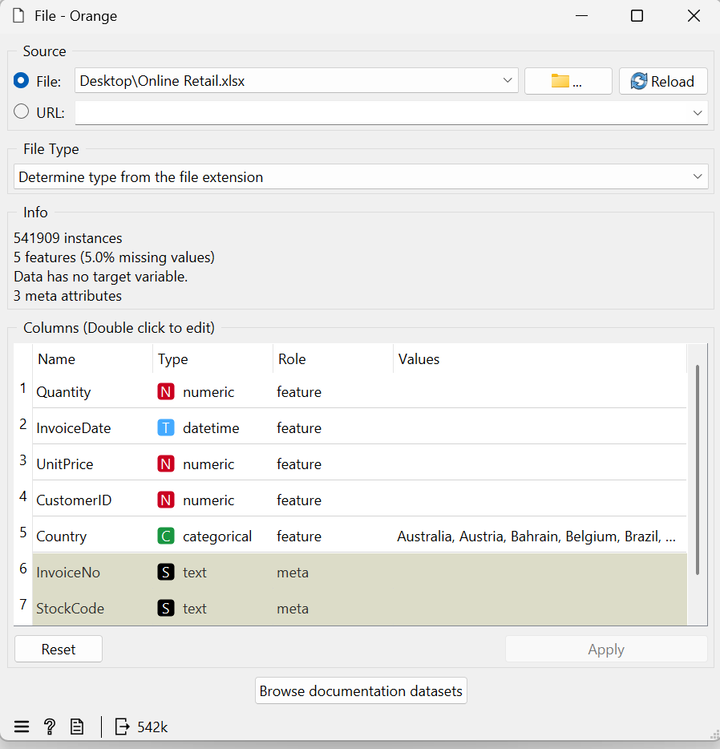

  - (a)Data preprocessing stage
The next step was the Preprocess widget. This widget was used to prepare the data for analysis. This included handling missing values and making sure that the dataset is fitting for additional preprocessing.
Figure 1.3: Data preprocessing using the Preprocess widget

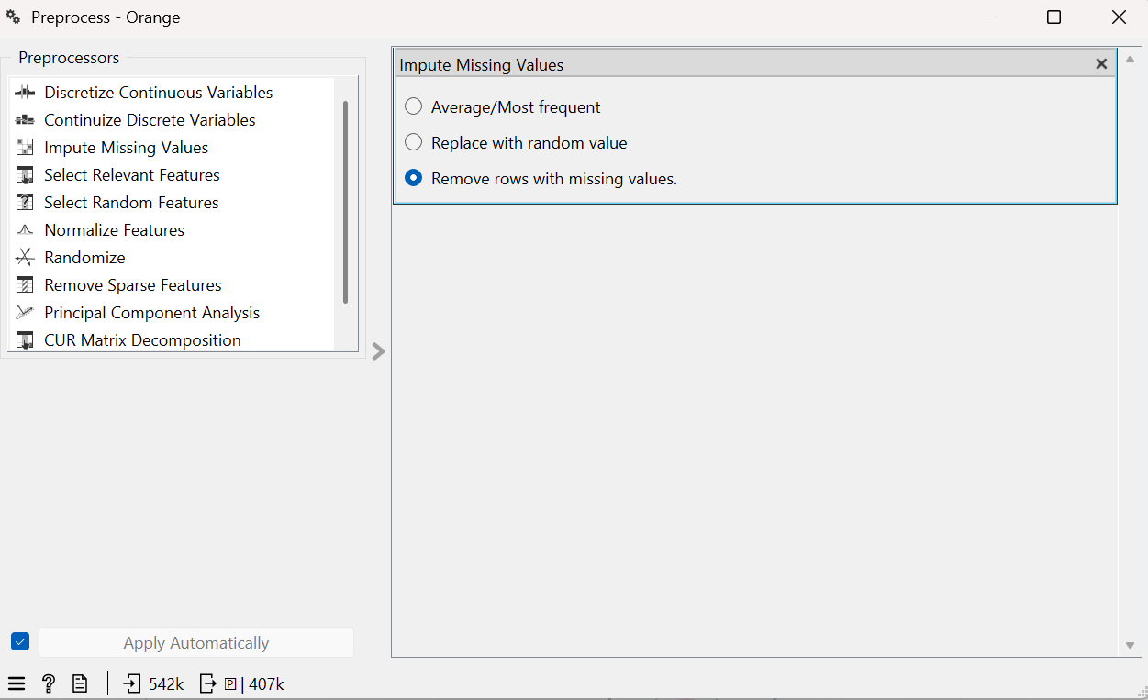

1.3(b) Data preprocessing stage
Figure 1.4: Data filtering using the Select Rows widget

The cleaned data is passed on the Select Rows widget, this is where only the records that are relevant to the study are retained for instance retaining only valid UK transactions.

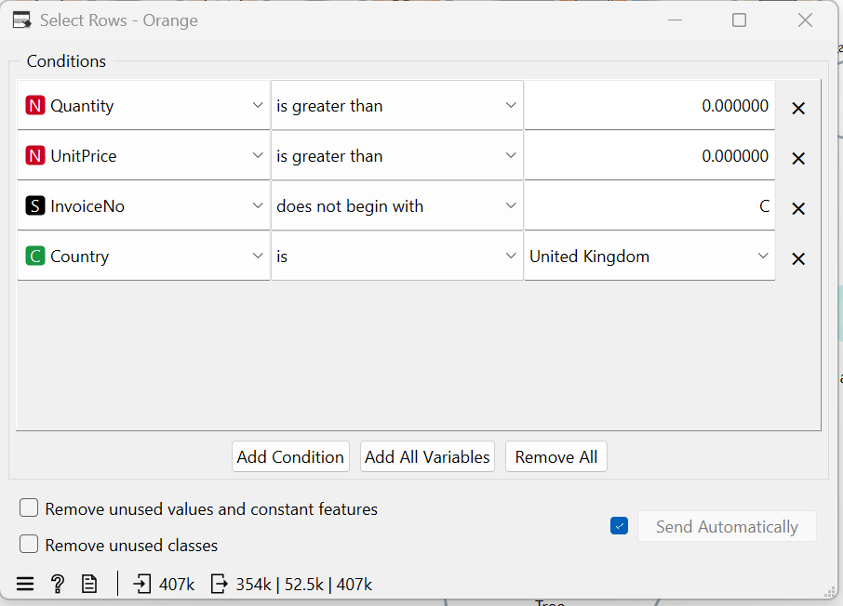

  - Group By (Feature Engineering)
The now filtered data is observed in Data Table (2) widget before being transferred to the Group By widget. At this point, the transactional records are aggregated at customer level so as to produce customer based behavioural features.
Figure 1.5: Feature engineering using the Group By widget

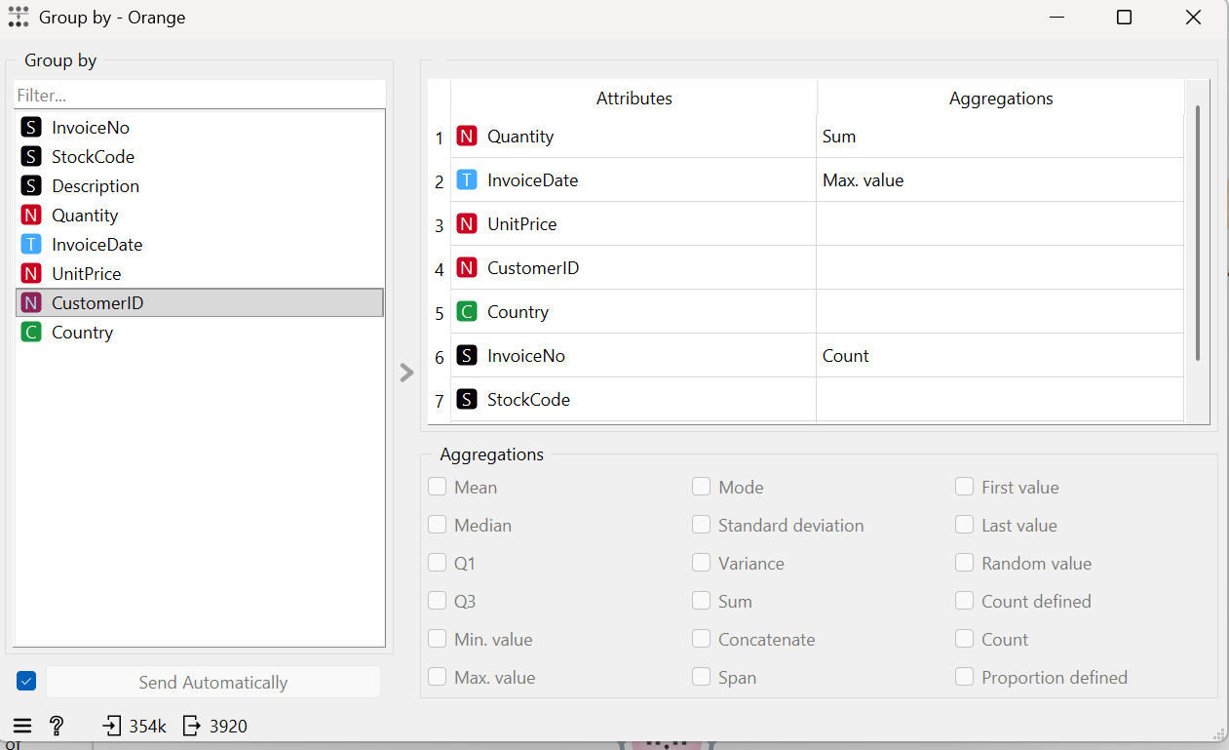

  - Edit Domain
The features are then moved through Edit Domain, this is where the variables are refined and prepared for the modelling process.
Figure 1.6: Feature preparation using the Edit Domain widget

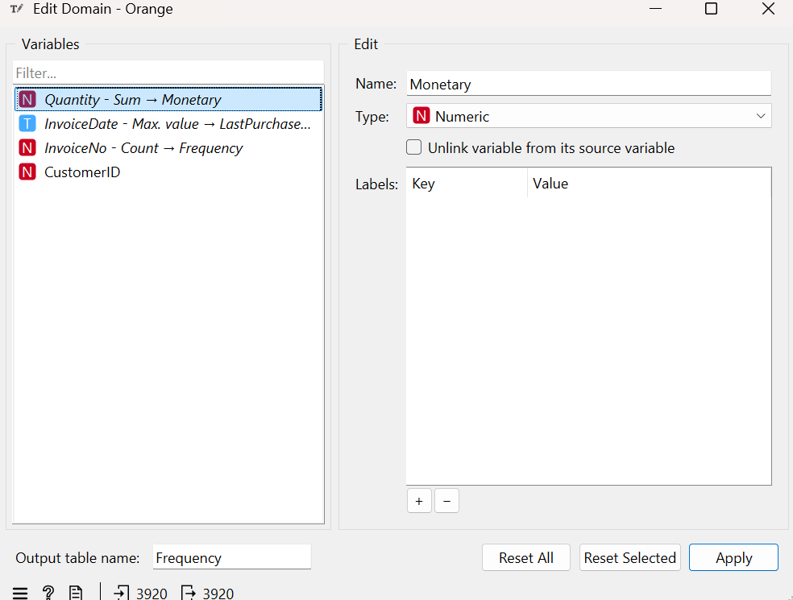

  - Python Script
A Python Script widget is used to generate the churn label predicated on the study’s definition of churn.
Figure 1.7: Churn label creation using Python Script

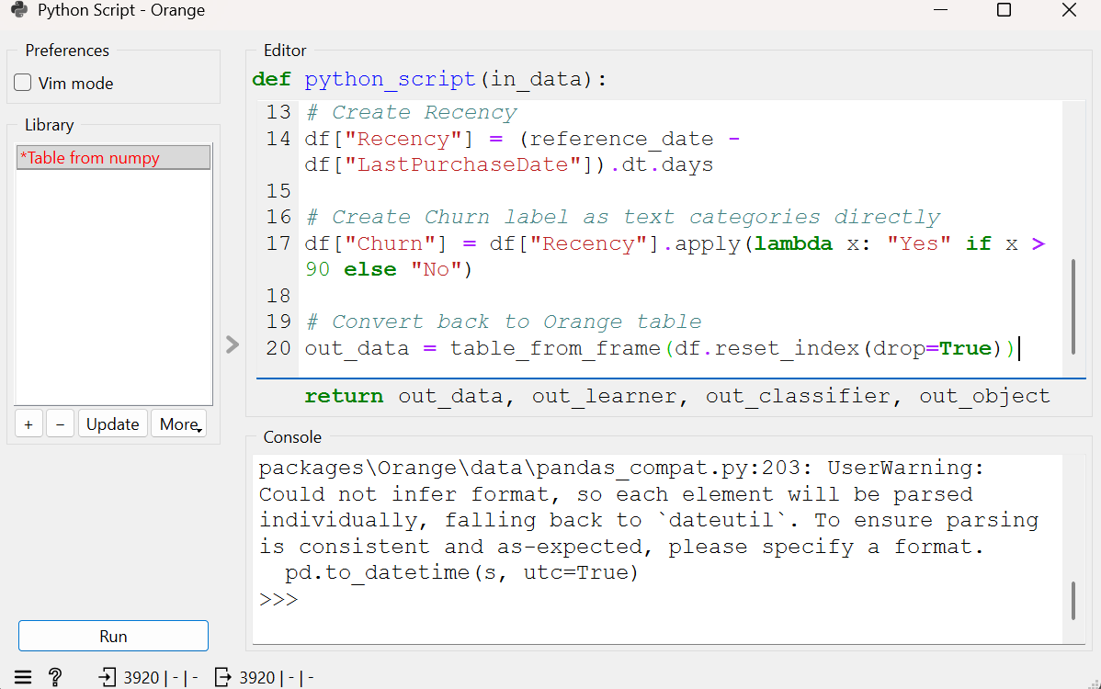

  - Select Columns
The script output is observed in Data Table (3) and then transferred to Select Columns, where the final predictor variables are selected and the target variable is assigned.
Figure 1.8: Selection of predictor variables and target variable
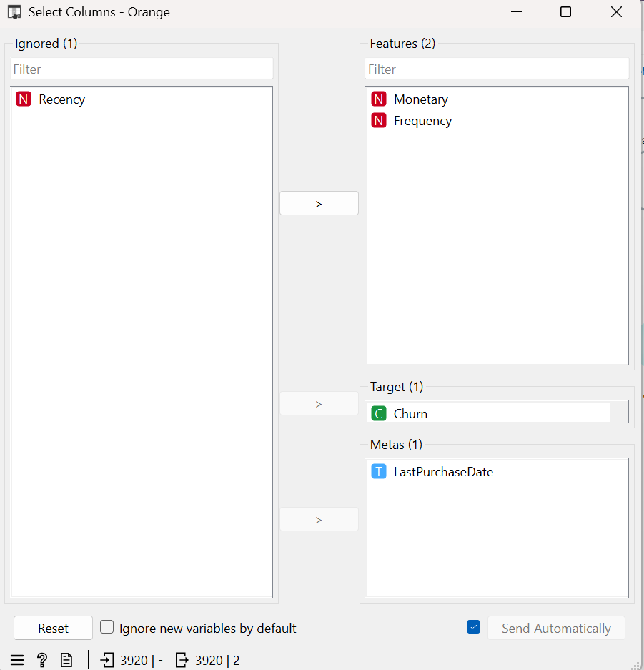

  - Test and Score
The now prepared dataset is then linked to the three machine learning models which are namely Logistic Regression, Decision Tree, and Random Forest. These three models are then sent to Test and Score and this is where their predictive performance is evaluated as well as compared using the selected metrics such as Accuracy, Precision and Recall.
Figure 1.9: Model training and evaluation using Test and Score

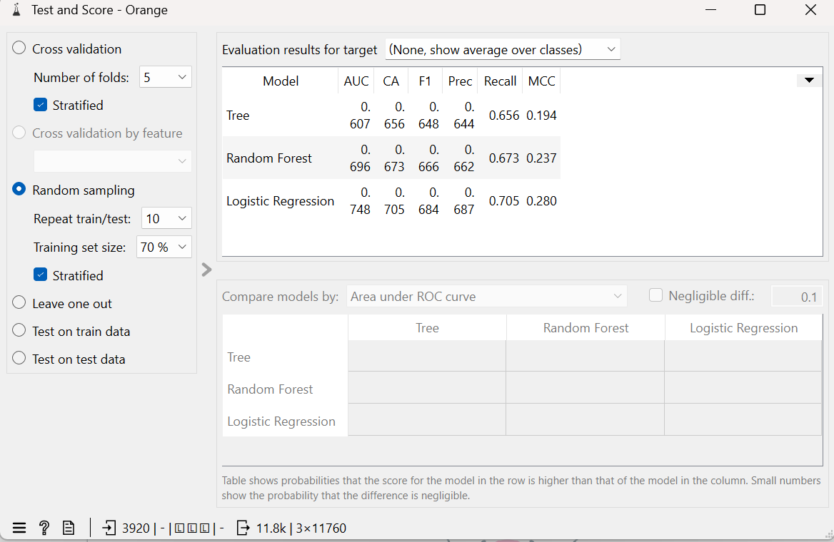

1.9 ROC Analysis and Confusion Matrix
Finally, the evaluation results are visualized through ROC Analysis and Confusion Matrix, which provide further insight into model performance and classification quality.
Figure 1.10: Model performance evaluation using ROC Analysis and Confusion Matrix
